## Module 1 - Creating Python Programs

## Pseudocode for Add/Subtract

Input number 1

Input number 2

Convert number strings to integers

If not a number, then output error and restart

Add number 1 to number and store into add_total

Subtract number 1 from number 2 and store into subract_total

Output add_total

Output subtract_total

## Pseudocode for Multiply/Divide

Input number 1

Input number 2

Convert number strings to integers

If not a number, then output error and restart

Multiply number 1 with number 2 and store into multiply_total

Divide number 1 from number 2 and store into divide_total

Output multiply_total

Output divide_total

## Add/Subtract Code

| def main():  # input two numbers  num1 = input('Input the first number: ')  num2 = input('Input the second number: ')   # convert the strings into regular numbers  try:  num1 = int(num1)  num2 = int(num2)  except ValueError:  print('You must enter a number.')  main()  exit()   # add the numbers together  add_total = num1 + num2   # subtract the numbers  subtract_total = num1 - num2   # output the results  print(num1, '+', num2, '=', add_total)  print(num1, '-', num2, '=', subtract_total)   main() |
| --- |

## Multiply/Divide Code

| def main():  # input two numbers  num1 = input('Input the first number: ')  num2 = input('Input the second number: ')   # convert the strings into regular numbers  try:  num1 = int(num1)  num2 = int(num2)  except ValueError():  print('You must enter a number.')  main()  exit()   # multiply the numbers  multiply_total = num1 * num2   # divide the numbers  divide_total = num1 / num2   # output the results  print(num1, '*', num2, '=', multiply_total)  print(num1, '/', num2, '=', divide_total)   main() |
| --- |

## Screenshot

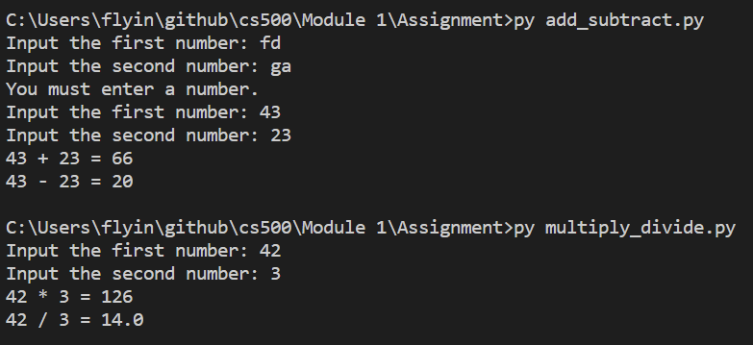

## Results

43 + 23 = 66

43 - 23 = 20

42 * 3 = 126

42 / 3 = 14.0

## GitHub Repo

<https://github.com/Dizolivemint/CS500/tree/main/Module%201/Assignment>